Bangladesh Medical Association (BMA)
List of Life Member-33
22. BMA Habiganj Branch

Sl No | Voter No | Voter Details
1 | Voter No  LM-2200001  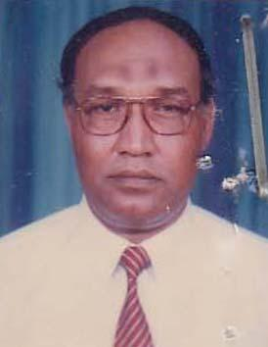 | DR. MD. JAMIR ALI  F/Name: Md. Lebas Ullah  M/Name: Khudeja Bagum  BM & DC Reg. No: 4990  NID: 3624406255244  Cell: 01711163760  Address: 4493, Shyamoli Residential Area, Habigonj  Blood Group: B+
2 | Voter No  LM-2200002  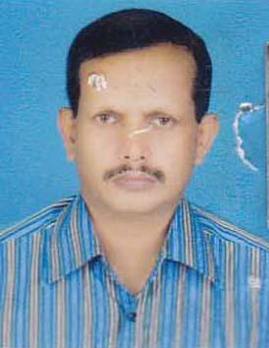 | DR. MD. MUSTAFIZUR RAHMAN  F/Name: Md. Taibur Rhaman  M/Name: Mrs. Anjumonoara  BM & DC Reg. No: 18111  NID: 3624409271828  Cell: 01711039420  Address: Consultant Surgeon, Adunik Jella Hospital, Hamiganj  Blood Group: O+
3 | Voter No  LM-2200003  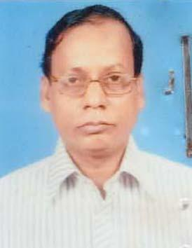 | DR. ASIT RANJAN DAS  F/Name: Late Adwait Charan Das  M/Name: Late Pankajini Das  BM & DC Reg. No: 11792  NID: 3624403240142  Cell: 01711941091  Address: Guning Park Habiganj  Blood Group: B+
4 | Voter No  LM-2200004  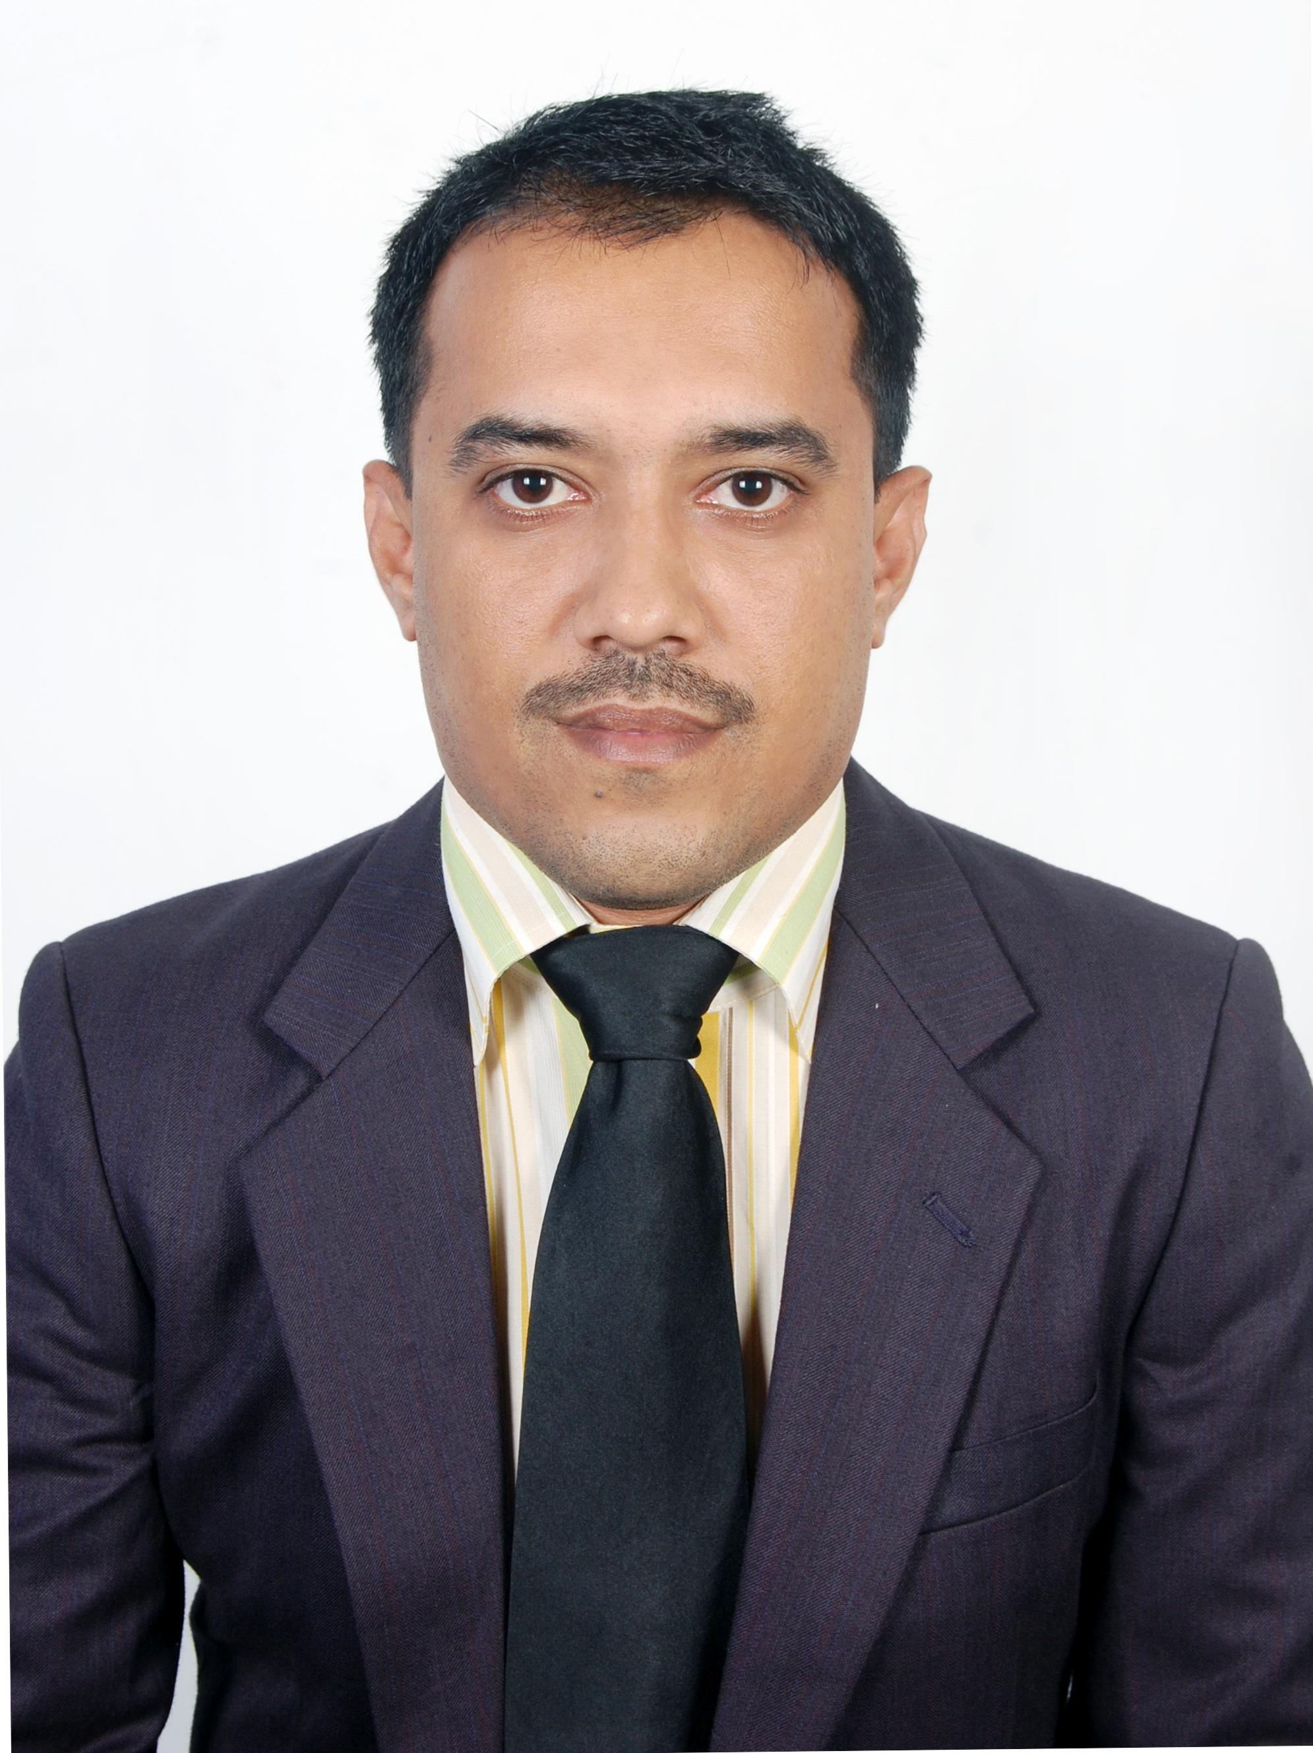 | DR. SYED MUHIBBUL ABRER  F/Name: Syed Abdul Wadud  M/Name: Janntun Nahar Chowdhury  BM & DC Reg. No: 33932  NID: 6885151875.  Cell: 01790888889  Address: Hasna Villa, Eidgah Road, P.O- Habigonj-3300, Dist- Habigonj  Blood Group: AB+
5 | Voter No  LM-2200005  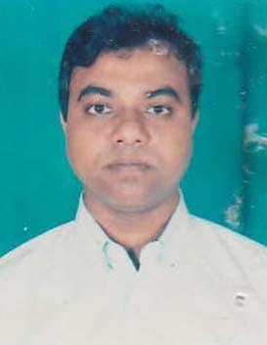 | DR. MD. DELWAR HOSSAIN CHOWDHURY  F/Name: Md. Abul Hashem Chowdhury  M/Name: Mrs. Khodeza Khanom  BM & DC Reg. No: 24043  NID: 3624408266459  Cell: 01712262770  Address: Adhunik Sadar Hospital Hobiganj  Blood Group: O+
6 | Voter No  LM-2200006 | DR. MUSHFIQUE HUSSAIN CHOWDHURY  F/Name: Late Allhaj Mvi Ahmed Hussain Chowdhury  M/Name:  BM & DC Reg. No:  NID:  Cell:  Address: Al-Rafi Hospital (PVT) Kali Bari Road Habigonj.  Blood Group:
7 | Voter No  LM-2200007  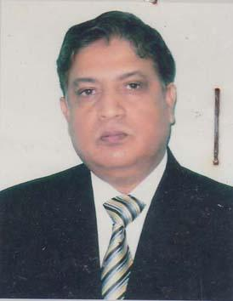 | DR. SHAFIQUR RAHMAN  F/Name: Late. Sujatur Rahman  M/Name: Shamsun Nahar  BM & DC Reg. No: 9483  NID: 3627702794630  Cell: 01711700583  Address: Civil Surgeon Office, Habigonj  Blood Group: B+
8 | Voter No  LM-2200008  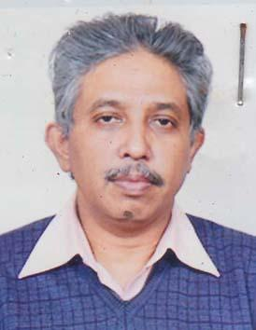 | DR. DEBAPADA ROY  F/Name: Late Harendra Lal Roy  M/Name: Late Provasinee Roy  BM & DC Reg. No: 14756  NID: 3624402238996  Cell:  Address: Upozila Health Complex, Baniachong  Blood Group: O+
9 | Voter No  LM-2200009  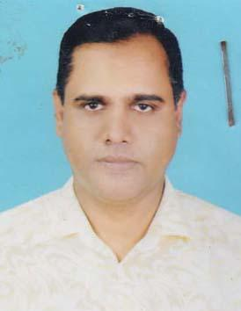 | DR. SYED MUZIBUR RAHMAN  F/Name: Late Syed Muzammilur Rahman  M/Name: Mrs. Hazera Begum  BM & DC Reg. No: 24734  NID: 3624404245012  Cell: 01711385316  Address: Pathologist, Adhunik Dristrict Sador Hospital, Habiganj  Blood Group: A+
10 | Voter No  LM-2200010  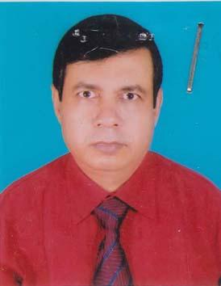 | DR. PROBASH CHANDRA DEB  F/Name: Late Kshtsh Chandra Deb  M/Name: Late Sucharo Rani Deb  BM & DC Reg. No: 18057  NID: 3624408265545  Cell: 01711585134  Address: Fire Service Road. Habigonj, P.O.+P.S+Dist.- Hobigonj  Blood Group: A+
11 | Voter No  LM-2200011  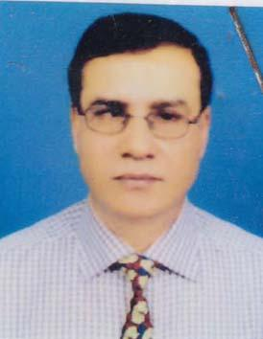 | DR. ARDHENDU DEB  F/Name: Late Upendra Chandra Deb  M/Name: Angali Rani Deb.  BM & DC Reg. No: 14852  NID: 3624405249421  Cell:  Address: Upazila Health And Family Planning Officer, Nabigonj, Upazila Health Complex, Dist. Habigonj  Blood Group: O+
12 | Voter No  LM-2200012  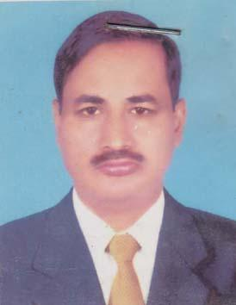 | DR. NISHIT NANDI MAJUMDER  F/Name: Late Phami Bushan Nandi Majumder  M/Name: Sudha Rani Nandi Majumder  BM & DC Reg. No: 14929  NID:  Cell: 01717720137  Address: Chunarughat Upazila Health Complex, Dist. Habigonj  Blood Group: B+
13 | Voter No  LM-2200013  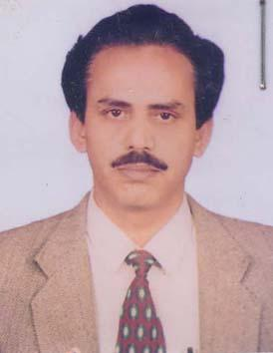 | DR. SUCHINAT CHOUDHURY  F/Name: Late Nitendra Lal Das Choudhury  M/Name: Late Sulota Das Choudhury  BM & DC Reg. No: 16696  NID: 19603624402437220  Cell: 01711327833  Address: Upazilla Health Complex, Ajmiriganj, Habiganj  Blood Group: O+
14 | Voter No  LM-2200014  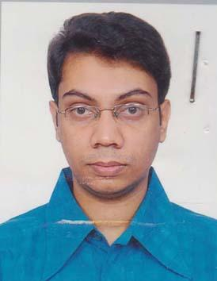 | DR. ARUNAVO DAS  F/Name: Dr. Asit Ranjan Das  M/Name: Tandra Das  BM & DC Reg. No: 51588  NID: 9196203121228  Cell: 01712-013349  Address: C/o: Dr. Asit Ranjan Das Gunning Park, P.O+P.S+Dist.- Habigonj  Blood Group: O+
15 | Voter No  LM-2200015  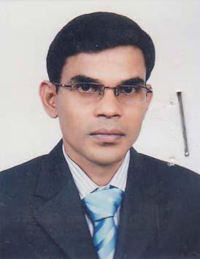 | DR. DEBASHISH DAS  F/Name: Ashutosh Das  M/Name: Promila Rani Das  BM & DC Reg. No: 47675  NID: 9196225384485  Cell: 01717509967  Address: Sador Hospital, Habiganj  Blood Group: B+
16 | Voter No  LM-2200016  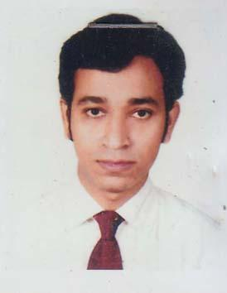 | DR. MD. REZAUL EKRAM  F/Name: Md. Ekramul Wadud  M/Name: Shahana Chowdhury  BM & DC Reg. No: 43903  NID: 3624405249882  Cell: 01717452523  Address: Wadud Mansion, Town Hall Road, Habiganj  Blood Group: O+
17 | Voter No  LM-2200017  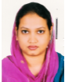 | DR. FERDOUSI ISLAM  F/Name: Md.safiul Islam  M/Name: Sofia Khatun  BM & DC Reg. No: 46340  NID: 2697556370648  Cell: 01712792511  Address: Sultana Villah,Chowdhury Bazar Habiganj.  Blood Group: AB+
18 | Voter No  LM-2200018 | DR. ARUN KUMAR PAL  F/Name: Salyendra Chandra Pal  M/Name: Joysuna Pal  BM & DC Reg. No: 38477  NID: 3923605133386  Cell: 01710972572  Address: B-2/D-3 Hospital Quarter , Habiganj Sadar Hospital  Blood Group: A+
19 | Voter No  LM-2200019  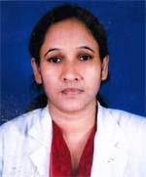 | DR. SABINA ASHRAFEE LIPI  F/Name: M. A. Ashraf Mozumder  M/Name: Mrs. Selina Begum  BM & DC Reg. No: 30618  NID: 3624404245011  Cell: 01711118261  Address: Prantik-B-58, Chirakandi, Res Area Habiganj  Blood Group: AB+
20 | Voter No  LM-2200020  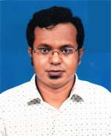 | DR. S.M. TAREQUL HOSSAIN  F/Name: Syed Mosharraf Hossain  M/Name: Sayeda Meherun Nahar  BM & DC Reg. No: 56060  NID: 2694814921491  Cell: 01819141743  Address: Station Road (Alom Vila) Habiganj Sadar  Blood Group: A+
21 | Voter No  LM-2200021  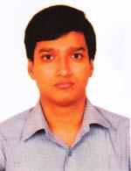 | DR. RAJIB CHOWDHURY  F/Name: Ranabir Kumar Paul Chowdhury  M/Name: Hera Paul Chowdhury  BM & DC Reg. No: 59934  NID:  Cell: 01720208848  Address: Judge Bhabon, Daudnagor Bazar, DhayesTaganj, Habiganj  Blood Group: B+
22 | Voter No  LM-2200022  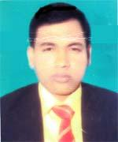 | DR. MD. ABDUL MUTALIB  F/Name: Md. Abdur Rashid  M/Name: Mrs. Alam Chan  BM & DC Reg. No: 45070  NID:  Cell: 01740950970  Address: East Lenjapar, Shaistaganj, pouroshova, Habiganj  Blood Group: A+
23 | Voter No  LM-2200023  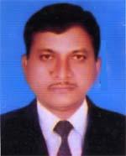 | DR. RATHINDRA CHANDRA DEB  F/Name: Late Narendra Chandr Deb  M/Name: Late Prioda Bala Deb  BM & DC Reg. No: 15928  NID: 3617714720079  Cell: 01720629844  Address: Upazilla Health Complex, Habiganj  Blood Group: A+
24 | Voter No  LM-2200024  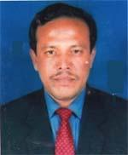 | DR. MD. ARSHED ALI  F/Name: Late Mohd. Iman Ali  M/Name: Late Mrs. Adurin Nessa  BM & DC Reg. No: 17751  NID: 3624409431291  Cell: 01711946957  Address: Consultant(Obs & Gynee). Sadar Hospital, Habiganj  Blood Group: B+
25 | Voter No  LM-2200025  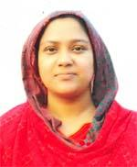 | DR. SHARMIN AKTER DIPA  F/Name: Md. Abdur Razzaque  M/Name: Khaleda Akter  BM & DC Reg. No: 55584  NID: 2698875392202  Cell: 01749098811  Address: East Lenjapara, Shaistagonj Pouroshova, Habiganj  Blood Group: A+
26 | Voter No  LM-2200026 | DR. FORHAD AHMED CHOWDHURY  F/Name: Ful Miah Chowdhury  M/Name: Amina Akter Chowdhury  BM & DC Reg. No: 63349  NID: 19882716469409550  Cell: 01725113309  Address: Farid Villa, Shyamoli R/A, Habiganj Municipality, Habiganj Sadar, Habiganj  Blood Group: O+
27 | Voter No  LM-2200027  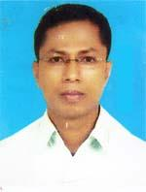 | DR. BABUL KUMAR DAS  F/Name: Ranjit Kumar Das  M/Name: Aroti Rani Das  BM & DC Reg. No: 31253  NID: 7218363148947  Cell: 01711202220  Address: Doctors Quater, Upazilla Health Complex, Bahubal, Habiganj  Blood Group: A+
28 | Voter No  LM-2200028  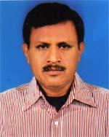 | DR. NAGENDRA KUMAR DAS  F/Name: Late Toroni Kanta Das  M/Name: Late Anandomoyee Das  BM & DC Reg. No: 15929  NID: 3624405251295  Cell: 01711973490  Address: Chirakandi (Radhanagar), Habigonj,  Blood Group: O+
29 | Voter No  LM-2200029  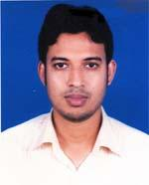 | DR. MD. MOKHLESUR RAHMAN UJJAL  F/Name: Md. Abdur Rashid Talukdar  M/Name: Mrs. Sharifa Khatun Chowdhury  BM & DC Reg. No: 50801  NID:  Cell: 01717278237  Address: Civil Surgeon office, Habiganj  Blood Group: A+
30 | Voter No  LM-2200030  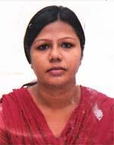 | DR. RUPA SARKER  F/Name: Gopesh Chandra Sarker  M/Name: Mamota Rani Talukder  BM & DC Reg. No: 57158  NID: 6125210181446  Cell: 01718744353  Address: Holding No.-1941, Gunning Park, Post+P.s+Dist-Hobigonj  Blood Group: AB+
31 | Voter No  LM-2200031  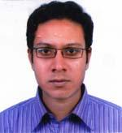 | DR. ATONU DAS  F/Name: Dr. Asit Ranjan Das  M/Name: Tandra Das  BM & DC Reg. No: 63713  NID: 19899196201102486  Cell: 01717057658  Address: Holding No. 1941, Gunning Park, po, ps: Habigonj, Dist-Habigonj  Blood Group: B+
32 | Voter No  LM-2200032  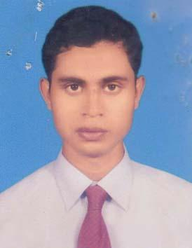 | DR. BIDUR KANTI SHAHA  F/Name: Nil Kanta Shaha  M/Name: Kolpona Rani Shaha  BM & DC Reg. No: 50061  NID:  Cell: 01717594483  Address: Vill- West Rupsangkor, P.O- Mirpur, Th: Bahubal, Dist- Habiganj  Blood Group: B+
33 | Voter No  LM-2200033  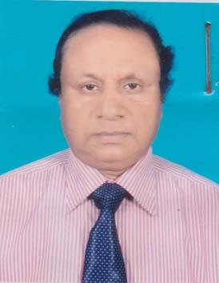 | DR. M. SULAIMAN KHAN  F/Name: M. Israil Khan  M/Name: Rahatunnesa  BM & DC Reg. No: 16879  NID: 9196213255882  Cell: 01712317778  Address: Upazila Health Complex Bahubal, Habigonj  Blood Group: B+

